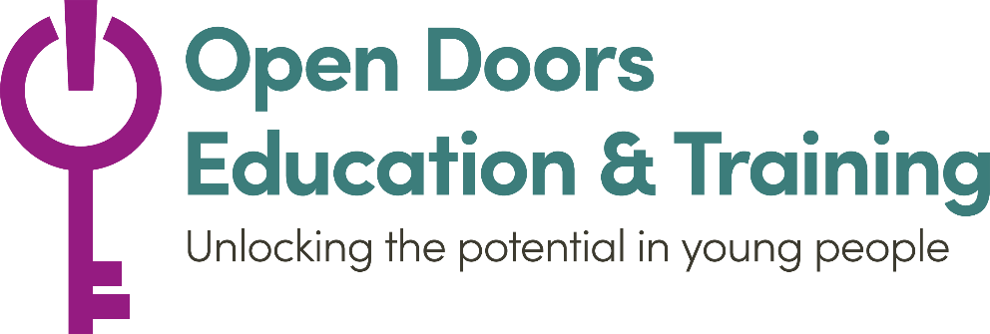
Open Doors Education & Training
Application form

Personal Details
Student Name
Age
Date of Birth
Gender (please circle) | female – male – other – prefer not to say
Ethnicity
Do you have any conditions or concerns which may require individual planning?

Address
Email Address
Mobile Phone Number
Emergency Contact Name
Emergency Contact Number
What days and times are the best time to contact you?

Education
Last time in formal education

Which project are you interested in?
Catch-up Programme |  | Functional Skills for NEET
Career Advice & Employability Skills |  | Other

IT Needs
Access to a laptop or tablet?
Broadband internet?
Smart Phone?

Availability
 | Monday | Tuesday | Wednesday | Thursday | Friday
AM
PM

How did you hear about this programme?

Why do you want to do this Programme?

Once completed, please email to info@odet.org.uk

