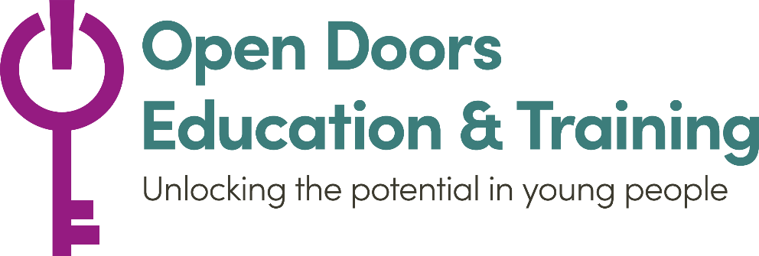
Open Doors Education & Training
Application form
Once completed, please email to Shane at education@odet.org.uk
If you need some assistance completing the form please call Shane on 07842 311 701
Personal Details
Student Name
Age
Date of Birth
Sex | female – male – other – prefer not to say
Ethnicity
Do you have any conditions or concerns which may require individual planning?

Do you have a SEN assessment?
Address
Email Address
Mobile Phone Number
Emergency Contact Name
Emergency Contact Number
What days and times are the best time to contact you?

Education
If you have left formal education, when was the last time you were in formal education

Which project are you interested in?
Catch-up Programme |  | Functional Skills for NEET
Career Advice & Employability Skills |  | Other

Technology Needs
Access to a laptop or tablet?
Broadband internet?
Smart Phone?

Availability – please mark all the times and days you are available
 | Monday | Tuesday | Wednesday | Thursday | Friday
Morning
Afternoon
Evening
 | Saturday | Sunday
Morning
Afternoon
Evening

How did you hear about this programme?

Why do you want to do this Programme?

We will try to accommodate your needs and find times and days suitable for you. However, is there anything you want us to know that might affect your ability to do the programme?

If three sessions are missed without cancelling in advance we will have to remove you from the programme, this is to allow someone else to have the opportunity who can commit to the full programme. Do you agree to this?

All of the information you provide is confidential, however;
- We will share basic information (your name, phone number and email) with the tutor assigned to you, this is to allow them to contact you to arrange your tutoring sessions.
- We will also store your information (age, sex, ethnicity, region you live in) this is so that we can report to our funders and improve our programme. We will never use your name or specific information.
- Do you consent to this? If you have any questions please feel free to contact us.
YES | No

Once completed, please email to our education officer Shane Curran education@odet.org.uk or call/WhatsApp Shane is you have any questions or need help completing the form on 07842 311 701

